Curriculum vitae of 9/2,Sarvodaya Road,
Miss. Jayakody Romen Harshana Sinna Urani,
0652225370, 0722222196 Batticaloa
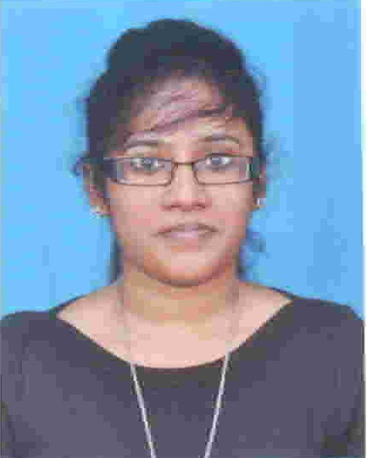

OBJECTIVE

To hold a challenging position in which can fully utilize my knowledge,
Experience and the ability in Information technology. My satisfaction comes from the knowledge of achievement of goals entrusted to me successfully by harnessing aspects of team work whilst to contribute my best IT knowledge to the organization.

KEY SKILLS / ATTRIBUTES

- Good knowledge in Information Technology.
- Ability to converse in English, Tamil & Sinhala.
- Analytical & fast learning.
- Ability to solve the problems.
- Capability to handle volumes & work under pressure.
- Achieving challenges.
- Maintaining high standards of work
- Maintaining Co-operation with sup ordinates and subordinates
- Ability to work continually to achieve Divisional and Co-operate objectives.

PERSONAL DATA

- Full Name : Romen Harshana Jayakody

- School Attended : Bt/St.Cecilia’s Girls High School

- Date of Birth : 25-11-1992

- Gender : Female

- N.I.C : 928300463v

- Civil Status : Single

- Nationality : Sri Lankan

- Race : Single

EDUCATIONAL QUALIFICATIONS

- G C E O/L’s in 2008
- Index.No: 82660786
- School : Bt/St.Cecilia’s Girls High School

Subject Grade
Religion A
English A
History B
Western Music B
Commerce C
Mathematics C
Science S
Tami S
Home Economics S

- G C E A/L’s in 2011
- Stream :Commerce
- Index.No: 2350513
- School : Bt/St.Cecilia’s Girls High School

Subject Grade

Economics C
Accounting S
Business Studies S
General English C
I.Q 45

PROFESSIONAL QUALIFICATION

- Completed the certificate course in Microsoft Office in HBS.
- Passed with Merit in Diploma in English in British College of Applied Studies.
- Completed EDHAT International Higher Diploma in IDM.
- Continuing CIMA in British College of Applied Studies.
- Passed “B” Grade in Certificate Examination In English( Intermediate Level) In Eastern University,Srilanka
- Awarded pass in the University of Cambridge ESOL Examinations (Key English Test) in 2007.
- Achieved in the University of Cambridge ESOL Examination (preliminary English Test) in 2010.

EXTRA CURRICULAR ACTIVETIES

- Awarded 1st place in National Level English Language Drama Competition.
- Awarded for successfully completing JCIV JA Company Program as a Product Manager.
- Participated in Australian National Chemistry Quiz in 2007.
- Participated in 06 hrs Holistic Formation & Leadership Training Workshop in 2010.
- Participated in Provincial level Software Competition in 2007.
- Participated as Guest Band in the Batticaloa District at the Musical Fiesta Band Competition in 2011.
- Awarded Merit-Silver medal Piano solo OC-12YEAR-Batticaloa at the
Srilankan Annual Competitve festival in 2005.

LANGUAGE SKILLS

- Tamil -Read, Write & Spoken Fluently
- English - Read, Write & Spoken Fluently
- Sinhala - Read & Spoken Good

WORKING EXPERIENCE

- Worked as a Data Entry Operator at GIZ-Temporary (Batticaloa)
- Worked as a Clerical Staff at Bharti Airtel Limited Batticaloa (6 Month Training) from 19th January 2013 to 4th August 2013.
- Presently I am working as a Cashier Cum Sales Executive at Etisalat Lanka (Pvt) Ltd in Batticaloa from 19th August 2013.

NON RELATED REFEREES

- M.Raamthilagar
Janashakthi Insurance PLC
(Zonal Sales Manager),
No : 55/77, Vauxhall Lane,
Colombo-02
0755666000

- John Baptist Fernando
(J.P)
18A, Govindon Road
Batticaloa
065-2224265

I do hereby certify that the above particulars furnished are true and correct to the best of my knowledge.

………………………….. ………………………..
Date Signature

